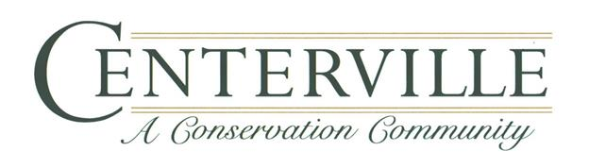

Centerville Conservation Community
Winter 2021 First Quarter Newsletter

President’s Message:
Welcome to 2021. I am sure we are all hoping this year lets us return to a more normal life than the one we just left. The first thing I would like to do as your new President of the Centerville Conservation Community board is to say thank you to our past President Mr. Jason Gassett and past board members Col. Bob Cohen, Mr. Brian Welch and Mr. Joe Bodiford for all their efforts in keeping our community the incredible place that it is. 2020 brought us some unique challenges. We had to learn to hold “Virtual” board meetings, we had to learn how to social distance from the neighbors we truly enjoy being with and our kids had to figure out how online school works. All that said, I think we did a great job as a community helping each other deal with the “New Normal” world.
As your Board President my main mission is to continue the effort to keep Centerville the unique and incredible place to live that it is and to protect the investment that we all have made in our community. In the past few months, we have done a deep dive into our current financial status along with the needs of the community in the years to come. We want to make sure we have planned for our day to day needs as well as the improvements and maintenance that our Community will require in the next 5 to 10 years and beyond. One thing that our work on the budget showed is that while our fund for future major projects like roads and fences is healthy it needed to be expanded to fully meet those requirements. That is why the board voted to raise the HOA dues by 5% this year and plans on additional 5% increases for the next 4 years as well. This will put us in a much more stable and positive position after that point and we believe that will allow us to meet our needs for many years.
I am happy to report that we have added 3 new highly motivated members to our board for 2021. Along with Mr. David Marshall’s land management committee and Mr. Paul Groom’s architectural control committee I think we have a great team in place to ensure the continued success of our community. Below is a listing of the 2021 board, along with their contact info. I look forward to a great 2021 and can’t wait till we can all get together again at the lake house for community social events!
Larry

2021 Board of Directors:
President Larry Lynch lwlynch01@earthlink.net
Vice President Debra Henley debrazhenley@gmail.com
Treasurer Andy Graybar atg7063@gmail.com
Secretary Kendall Stahl ktstpa@msn.com
Director Kelly Hittinger kmunro59@gmail.com

Board of Directors Meeting schedule for 2021
The CCCHOA Board welcomes your attendance at our Meetings every 2-3 months, some we are able to do in person, others we do via online (Due to COVID), weather, daylight savings.
March 2nd – Board Meeting
May 5th – Board Meeting
July (TBD) – Board Meeting
September 7th – Board Meeting
November 2nd – Board Meeting
Meetings times and location to be determined, please check the website as well as entry gates for notices and agendas ahead of scheduled Board Meetings.
ACC Committee meets the first Thursday of each month at 9am, and this due to COVID has been and will continue to be online (if wish to attend please email Ray Holloway in advance or Micah Dodstone).
Land Management has their next meeting Saturday, February 20th at 3pm at the Lake House, anyone who wishes to attend please practice Social Distancing and wear a mask.
Treasurers Report:
CCOA ended 2020 in good financial shape. We added $90,000 to Reserves. In 2021, we expect $278,000 in spending, including replacements. Barring anything unforeseen, in 2021, we should add $45,000 or so to Reserves, and anticipate $305,000 of Replacement expenditures over the next 5 years. The big hurdle will be resurfacing our 7 1/2 miles of roads, at a cost near $1 million in about 10 years. Opinion: At this time, we do not predict any special assessments, provided we just increase dues by 5% annually. You can see the 12/31/2020 Balance Sheet on our website. We will add financial data to the website quarterly.
Andrew Graybar, Treasurer
From the Land Management Committee Chairman:
What is going on with that white stuff on the side of the roads?
What you are seeing is road base limerock that is placed to provide subgrade support for the asphalt roads. In a number of places throughout the neighborhoods traffic has continuously run off the edges of the roads to the point that is some areas the support has failed and asphalt has begun to collapse. We are trying to build these edges back up to prevent further damage. All the roads in the neighborhood are 22 feet wide, ample room for two 8-foot vehicles to pass. Granted we have lots of curves but that is usually the area where most of this is occurring. In attention to driving, higher speeds (remember we have a 20 MPH limit) and failure to keep an active eye on road conditions, all lead to this type of run off.
The upkeep of these roads is our responsibility, not Leon County’s. When the road structure fails, it will cost all of us as lot owners personally. Help us preserve the road structure while driving by taking care at curves, corners and stops. And, please “keep it in the road.”
Mind the Speed Limit (20 MPH)
Remember the neighborhood’s 20 MPH speed limit. (Remind family members and visitors as well) The roads seem narrower when you are going faster and so far, we have had three deer, a cat, and at least four fox squirrels killed due to traffic.
We have also had a number of areas where traffic has run off into the grass. With our winter rainy weather, the clay soils have become very soft and allows for rutting very easily. Please stay on the pavement as much as possible.
Fall Burn Results/Upcoming Burn Plan
We had three days of prescribed fire in December, much later than we had hoped to achieve but a combination of COVID, permits and weather conspired to delay often.
Some areas burned well and the forest floors are very evident. In other areas, we saw less success due to the overstory and midstory growth that has inhibited growth and accumulation of fire fuels on the ground. We have changed our plans this past year and going forward and are going to move to a plan to burn a portion of the properties every year but alternate those areas to allow for an approximate two-year cycle. Past practices of annual burns have allowed hardwoods such as laurel oak, hickory and sweetgum to become established creating that midstory layer that has prevented effective burns. This midstory also limits the amount of herbaceous growth that feeds the wildlife such as deer, turkey, quail and gopher tortoise. Once we get this plan into effect, we will once again be able to see the “park like” vistas that we expected to see and that were planned for.
The second series of burns will begin again in late March/early April. In those areas burned in December, we have begun the process of mowing down some of that midstory which may have to be followed up with herbicide treatment to knock back the hardwood growth.
All of our efforts have been in consultation with Tall Timbers, our professional burn contractor Attack 1, Leon County and our professional forester Stan Rosenthal.

Who You GONNA Call? (no not the Ghostbusters)
Many of you have asked for a handy dandy guide on who to call for various needs in the community. We have put together the following list so far, and will do more work on it over the next few weeks. This list will also be posted to our website.
Dead animals: Let’s try really hard to drive the speed limit and take extra care at night, so we don’t have any more dead animals on the roads, but for dead animals call Rich Leterra at (850) 510-1734.
Overflowing trash cans: normally Rich handles these. The trash can at the parking area for the pedway is abused heavily, broke again and was removed. We are working this issue out with the county.
Potential criminal violations and trespassing: Contact the Leon County Sheriff’s Office. 911 emergency or non-emergency, (850) 606-3300.
Gates broken or not working: Try calling TPAM first, and if you cannot get through, contact a Board Member via email, text or phone call.
Need a remote: Contact TPAM, please remember the $25 remote purchase price must be paid before one will be mailed out to you or delivered if you able to wait for one of the two monthly Inspections the Association Manager performs.
Street lights out: Talquin has a good website tool for reporting outages of those kind, they only need the light post number. You may also contact David Marshall or Rich.
Centerville Trails Map: This map is on the website, as are our golf cart policies, covenants, design book, and other important and useful documents.
Barn/Pasture rental: Contact TPAM. Forms and policies are on the website.
Lake House rentals: - Contact TPAM. Forms and rental policies are on the website. NOTE: We are not accepting Lake House rentals at this time due to COVID. The Board will revisit at the next board meeting.

Conservation Corner:

Coyote Season—Keep an eye and ear out…
The Florida Fish and Wildlife Conservation Commission is warning pet owners to keep their eyes peeled as the state enters peak coyote season. Coyotes are a particularly unfriendly species of canine, and we have plenty of them in CCC, that love to prey on their domesticated cousins as well as cats. Like other predators, Coyotes are mostly drawn in by food, so FWC recommends securing or removing any sources of temptation — trash bins, bags of pet food, and pets.
“Cats should be kept inside for their protection as well as to protect songbirds and other native wildlife cats’ prey upon,” Kaufmann said. “When walking dogs, keep them on a short leash, especially at night, dusk or dawn, and be extra careful when walking your pet in wooded areas.

New Features on the Centerville and Pisgah Church Road PEDWAY;
The Benches and Nature Information Kiosk on the Pedestrian Way, (PEDWAY) did not grow out of the ground (in case anyone was wondering) They are a result of the initiative, hard work and leadership of 2 Centerville Community Siblings, Macey and Major Hartman. They and the members of Troop 45 all wish to thank the Centerville Conservation Community Owners Association for agreeing to be the Eagle Scout Service Project Beneficiaries, and also express their sincere gratitude to Mr. David Marshall and Mr. Jason Gassett for the important roles they fulfilled for both projects, as Eagle Scout Service Project Construction Coach and Beneficiary Representative, respectively.
Centerville Conservation Community is proud to have these useful and informative features to make our community a better place to live and play. Thank you, Macy and Major for dreaming up this project that will be appreciate and enjoyed for years to come.
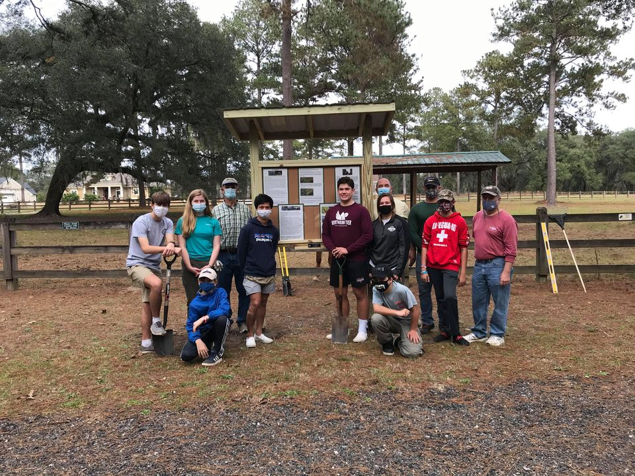
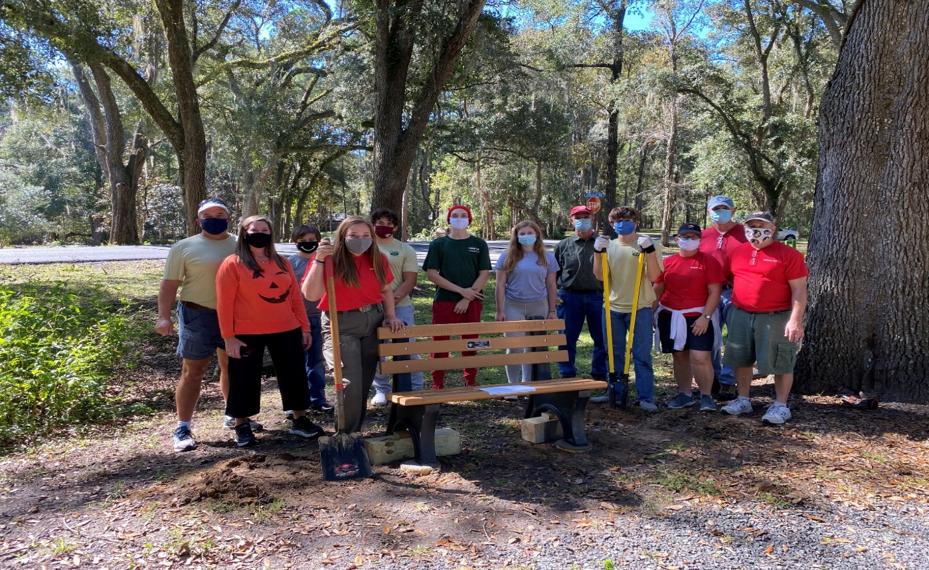

Newsletter Items:
If anyone has items of community interest to include in our quarterly newsletter, please send them to Debra Henley, at Debrazhenley@gmail.com

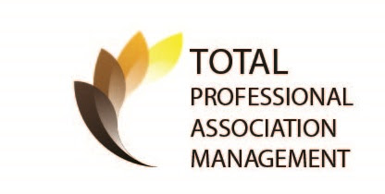
Managers Corner:

From your Management Team at TPAM:
As we begin the new year with hope and promise of a better year than 2020 was to all us, we wanted to make you aware of what we do at Centerville Conservation Community. As your Association Manager, I perform two complete Neighborhood Inspections each month (where we are looking at compliance items), and I will say there have been fewer occurrences. Most of the covenant violation issues relate to boats, and trailers, and we appreciate everyone’s effort in making this less of an issue for all. When performing inspections, I also inspect the common areas to ensure the Landscape is being well maintained, that the Lakehouse is clean and not in need of any pressure washing, painting or other repairs. I check the Horse stables and look for any notable issues with fences and bridges that may come up. I look at signage to ensure it agrees with the covenants and restrictions. With this being a Conservation community, I am particularly sensitive to damage to our common areas from Construction traffic, contractors doing work for owners by accessing our nature trails and parking in areas they shouldn’t. We try hard to inform owners and vendors alike when they are doing something that violates the covenant and restrictions of the Community and work hand in hand with them to curb this quickly. We understand and respect everyone’s privacy and never wish to impede upon that.

Aside from my monthly inspections, I work closely with the ACC and the volunteer committee as well as Dodstone Architects. This is a very big and important faucet of the duties I perform for Centerville, we have so many owners who wish to make improvements to their property and submit requests as such and the ACC serves to protects everyone’s investment they have made at Centerville. One of the items I would like to point out that some owners may not be aware of is the procedure from removing trees from your property, yes even dead ones. I realize it may seem cumbersome to have to follow procedures to remove a dead tree but again this is simply to protect the integrity of the Community. I promise it is really simple and if you chose to remove a dead tree as most certainly would, all you would have to do is either have an Arborist come out and inspect and write a letter to the effect that the tree is dead or trees are dead, submit this letter to me or simply email me or even David Marshall of the ACC and we can inspect the tree as well and, in most cases, a dead tree is easy to see and agree upon. I can do this in one of my two monthly inspections or David may be able to do it sooner as he is on site often. I want to stress David volunteers a lot of his time to the betterment of the community and he too can get busy but the bottom line is please don’t simply circumvent this process and have trees cut down without approval, dead or alive. There is a different process you will need to follow if you wish to remove trees that are healthy and those guidelines are on the website. I am pleased to see more horses out here using the stables and pastures than before, if you wish to board your horse here, please contact me as well as look at the forms we will need to obtain from you on the website in advance of you boarding you horse or horses here. I know there is much more I could go into as far what we do for Centerville but I don’t lose what audience I have. If you contact me or TPAM in general, please allow up to 48 hours to reply, we are not onsite Management so we remain busy in all aspects but we will get back to you within 48 hours not counting weekends. I will share some other contacts to use for certain needs that my support staff can also assist you with,

- If you have questions regarding your account or billing, please email us at billings@tpam.biz
- If you have questions general questions regarding the Association, please email me at ray.holloway@tpam.biz
- You can also call us 24 hours a day, 7 days week with any Emergencies at (850) 583-1173
- When the Lakehouse eventually opens back up for rentals, or you wish to Board your horse or horses here, you can email me again or you can email customerservice@tpam.biz
Thank you all,
Ray Holloway, CAM
Centerville Conservation Community

We encourage all homeowners to familiarize yourself with the documents and for your convenience they are located on Centerville Conservation website: http://www.centervilleconservation.org/documents.htm

